

**Course Code:** MKTM503 **Course Title:** MARKETING MANAGEMENT– I

**Course Instructor:** Dr. Rajesh Verma **Section:** Q2240

**Academic Task No.: 1 Academic Task Title:** Assignment 01

**Student name:** Nowneesh T  **Date of submission:** Sep. 27, 2022

**Student’s Roll no:** RQ2240A14  **Student’s Reg. no:** 12202342

**Evaluation Parameters**: (parameters on which student is to be evaluated-to be mentioned by students as specified at the time of assignment the task by the instructor)

**Learning Outcomes: (Student to write briefly about learnings obtained from the academic tasks)**

**Declaration:**

I declare that this Assignment is my individual work. I have not copied it from any other student’s work or from any other source except where due acknowledgement is made explicitly in the text, nor has any part been written for me by any other person.

**Student’s Signature*: Nowneesh T***

**General Observations**

**Suggestions for Improvement**

**Best part of assignment**

**Evaluator’scomments (For Instructor’s use only)**

Evaluator’s Signature and Date:

Marks Obtained: Max. Marks:

**MedRef - a mobile/web application**

**INTRODUCTION**

Over-the-counter (OTC) pharmaceuticals are medications that are offered directly to a consumer without the need for a prescription from a healthcare provider, in contrast to prescription drugs, which may only be delivered to customers with a valid prescription. OTC medications are chosen by a regulating body in several nations to guarantee that they include components that are secure and efficient when taken without a doctor's supervision. OTC medications are often controlled based on their active pharmaceutical ingredient (API) rather than its finished goods. Governments give firms the leeway to combine different chemicals into proprietary mixes by regulating APIs rather than particular medication formulations.

When a drug is referred to as over-the-counter (OTC), it means that it can be acquired without a doctor's prescription. Contrarily, prescription medications need a prescription from a doctor or other healthcare provider and are only to be used by the person who has been prescribed them. Some medications may be categorised legally as over-the-counter (i.e., no prescription is necessary), but only a pharmacist may deliver them after determining the patient's requirements or providing patient education. Different countries have different laws governing the places that can sell pharmaceuticals, who is allowed to distribute them, and whether a prescription is necessary.

We have to regulate the OTC drugs consumption with a certain level of mixture with the chemicals. For that we have to develop a product like software application to regulate or monitor the OTC consumption to prevent side effects to the patients and the normal consumers. The most of way of consuming this type of drug product, doctor prescription is needed. Because doctor knows that the certain level of the drug of OTC will cure the patient’s illness or the problem. As certainly doctor mention the level of drug should be consumed. So, if we have to regulate the OTC drug, we have to create an app and we have to provide awareness of the app.

The aim is to create a software product named “**MedRef**”. The main motive of this product is to address the misuse of Over the Counter (OTC) drugs, provide a guidance system that educates users whether OTC drugs are recommended in each scenario or should the user be consulting a doctor.

**Bases of Segmentation used**

In the development of the new product, we must know the requirement or which type of features should be added in the product to provide good service to the customers.

The some of the features are

* To enable a broad consumer base, the solution will have capabilities including voice-based questionnaires and multilingual questionnaire support.
* Based on age group, gender, and other pertinent factors, dosage and other considerations will be estimated.
* Each medication's side effects will be clearly described, along with a suggestion.
* The suggestion of alternative medications (brands) is a feature.
* Subject to regulatory restrictions, the information gathered may be used to improve the list of over-the-counter medications.
* Subject to legal restrictions, data obtained at the user level can be used to anticipate or advise the user for further recommendations.
* a feature that allows users to provide feedback after each recommendation, using the information to improve the app or database.

The type of segment, we are going to use here is **demographic** segmentation and minor use of other segmentations are **Behavioural** and **Geographical**.

This segment is used mostly because we must consider observable non-character factors like:

• Age

• Gender

With the help of this segmentation, we are able to promote the application very easily. Because we are able to categories people with both age and gender.

We are able to mention that who should consume the certain mixture of drugs and if certain kind of people are trying to choose wrong option, with the help of our data, we are able to suggest some alternative to pick the right one. This will help customers not to consume high dosage drugs.

**Accuracy of used segmentation basis**

The segmentation of the product was founded with the help of the key features like age and gender. We can choose two type of segmentation which is related to the product, we will develop.

The used segmentations for this applications are

* Demographic Segmentation
* Geographical Segmentation
* Behavioral Segmentation

**Demographic Segmentation**: We are going to categories people according to their age and gender. We can gather the details of each customer with registration part of the application.

**Geographical Segmentation:** Our product should reach each and every people throughout the countries. Each and every people are using different languages. So we have to add more new language for the people who are all comfortable with their native language in purchasing products.

**Behavioural Segmentation:** With the help of this segmentation, we are able to know the behaviour of the customer like frequency buying the product, benefit sought etc...,

With the age segment, we are able to provide advertisement related to each and every age category people. Then we can provide different types of offers to them like discounts.

With the help of gender segment, we are able to gather which gender is consuming the product frequently.

With help of geographical segment, we can get the knowledge of places and region about the condition of the weather.

**Market Targeting Approach**

For this product, we are going to do **segmented marketing.**

**Reason:**

* If we go with segment marketing, we are able to provide different types of promotion and advertisement to the categoried customers.

For example : we will provide “deals of the day”. It will attract customer to enter into our application.

* We can provide different kinds of offers to each categoried customers. Because with the more variety of products, we are not going provide the same kind of product with the same mixture of chemical in it. According to their age and gender, customer can order their OTC product.
* With this marketing approach, we will gather information about that which segment will consume more OTC product with which type of mixture. This will help pharmaceutical company to increase their production of the OTC drugs in the correct manner. Then there will no high wastage or expired OTC will available in the market.
* This generation is literally trying to use each and every source. So, we will provide them coupons for buying the product(drug) with our application. In this time, Coupons play a major role in bring the customer to us simultaneously because the customer is ready to waste the coupons. So it will be helpful for us.

**For example:**

The male customer with age of 23 is going to order an OTC drug. He is going to order a high dosage drug which should not be delivered without any prescription. So, At the point of time, we are going to suggest him the same kind of drug with low dosage. From this point, the customer is also able to consume the drug and he is not have the capacity to get high side effect with the low dosage drug.

**Positioning strategy**

**Characteristics-based positioning**

We have to provide the quality of OTC drug with the best suggestion option, so the customer will know our application is providing higher quality OTC drugs with correctmixture rate.

**Pricing-based positioning**

Based on segment division, we will make offers according to the needs of the specific category of people. We will help poor and needy people to buy the OTC product with the help of medical shop.

**Use or application-based positioning**

We can also add new feaure like communicating with the doctor, it will attract more customer because they can purchase best product as per their needs.

**Quality or prestige-based positioning**

With the quality and price, we can attract them by providing ratio of mixture of chemical in their product. So the people will know about the quality of our product(drugs) very easily.

**Competitor-based positioning**

In the medical industry, there are more competitors with high wealth because of Covid-19. In recent news says that DOLO-650 is the product brought by the people during covid situation.

**Analysis of evolving needs of customers**

* After attaining the good position with the customers, the application should need more updation as per the needs of the customer.
* We providing OTC drugs with application, sometime the person need suggestion of the doctor. Then we need to add a new feature for customer to interact with the doctor to get their product through our application.
* We should include the side effects of certain product after the consuming high dosage. Then only the customer will get awareness about their product(application).
* With the help of the application, we have to make available 24/7 because at late night also customer need our product(drugs). So the application should be compatible with both android and website applications for easy use.
* Customer have to give the review of the specific purchased product(drugs). With those suggestion in the application, the other customer will be those drugs frequently.

**Justification for new product development**

We are going to create a software for OTC drugs.

* First, built registration page which we have to link with their aadhar card for the verification of the age and gender. For some drugs, it is not needed.
* The application should contain more security features.
* The feedback section should be available for every customers.
* Incase customer had a doubt to buy with type of OTC drug, they can contact doctor through our application.
* We will reduce the price value for the certain period of the products in our application. If we lowered the price and increased in quality that will attract more to buy product through our application.

**Launching time and Place of the Appliction(APP)**

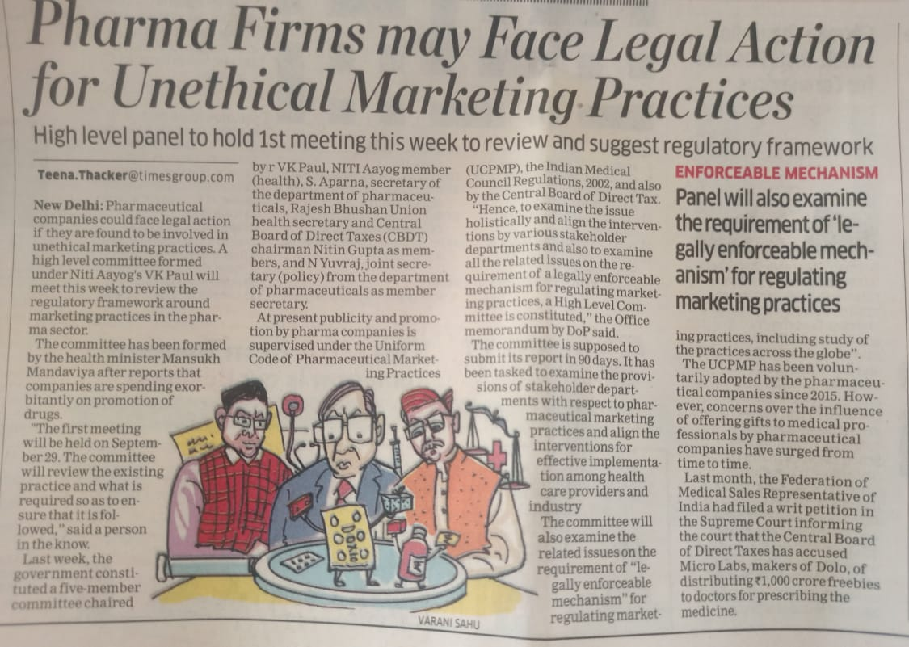

According to the recent news shot from the economic times which was mentioned above.

From the news of **September 27,2022** **Page no:12**, Pharmaceutical company is distributing the drugs unethically to improve their revenue. This news will help us to launch our product(application) to regulate the OTC drugs, then only we can stop these unethical sales of the OTC drugs from pharmaceutical industry.

* To investigate the drugs related issue, government formed the committee to monitor these industry.
* We have introduce our application to the government healthcare department, definitely healthcare dept will approve this type of approach to connect with the customer and we have to promote our product through government website itself. So we can spend low amount for promotion of the application.
* According to the place, we should launch this app to each and every private and government medical shop. Then our application will reach more high and we are able to make the revenue through the application.
* With the addition of above mentioned, we should update the delivery history to the customer. So, the customer is able to believe our products(app).
* At first, we have to capture more customers. It will help us to improve the service.
* According to the idea of each and every product in sales” First impression is the best impression”. We can achieve those impression with the government support. Mostly the people is believing or providing their hope to the government which was formed. So the people will gain more trust of our application.
* After achieving the hope and truth, we have to maintain that service and quality. So, the application should be available each and every time and also made connections with nearby pharmaceutical or medical shop.
* For example: If the application was not available all the time then people may able to lose their hope and trust. Then it will decrease the sales of the OTC product through our application. So, we have to improve or update our product in weekly or monthly manner.
* Atlast after acquiring the market, we have to maintain the trust of the customers by providing quality services to them.

**Thank you**